Autopilot
Objective
This guide was created after several unsuccessful attempts to upload the hash of a machine in Country A and then ship the laptop to Country B for deployment. This workaround is based on the principle that the hash must be uploaded from a browser located in the deployment country. Additionally, the guide details how the IT team can enroll an old, existing (and accessible) laptop located at a remote site into Autopilot for deployment.
Estimated Time
It will depend on the number of pending Windows updates and drivers. An up-to-date device will take approximately 45 minutes.
Step-by-step Instructions:
- Download the GetAutoPilot.zip file. It is located in the Autopilot Folder.
- Extract all folder contents to 'Documents' (C:\users\%username%\Documents)
- Open CMD in 'Admin' mode and run the command 'GetAutoPilot.CMD'
- This will generate the compHash.csv file.
- In the remote machine's browser, access Contoso Inc. - Microsoft Intune admin center and log in with the PS account.
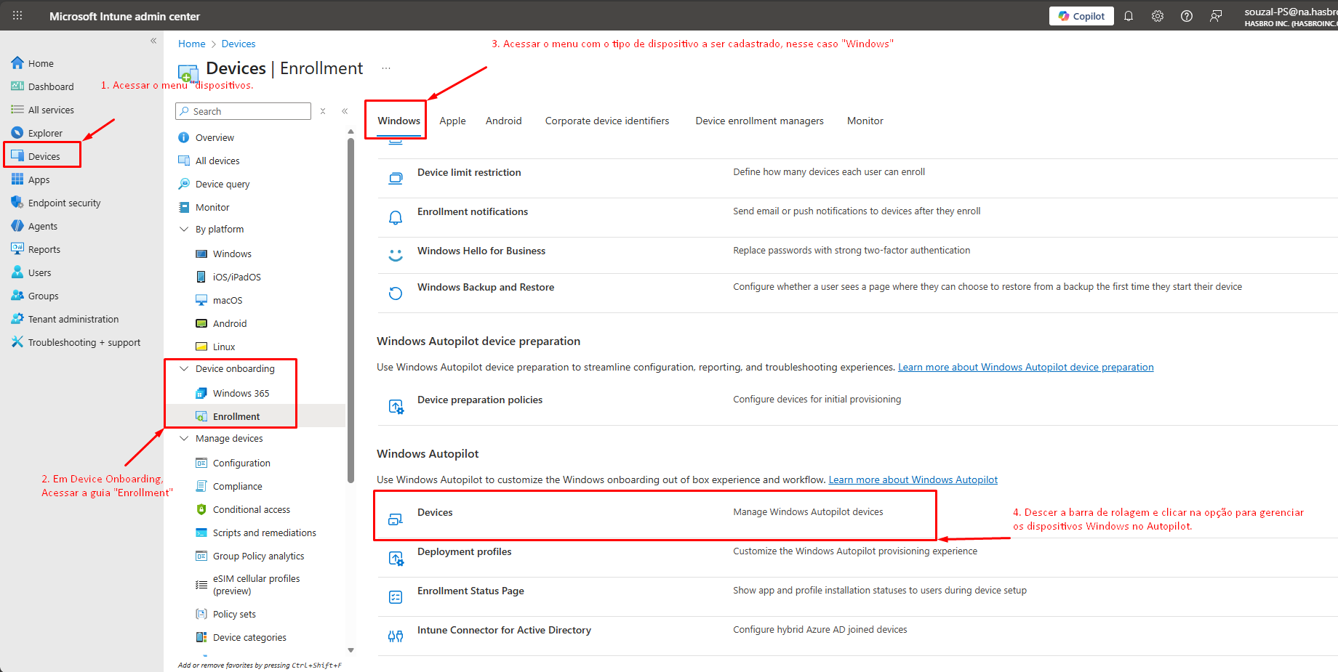
- On the following page, you must import the generated CompHash.csv file.
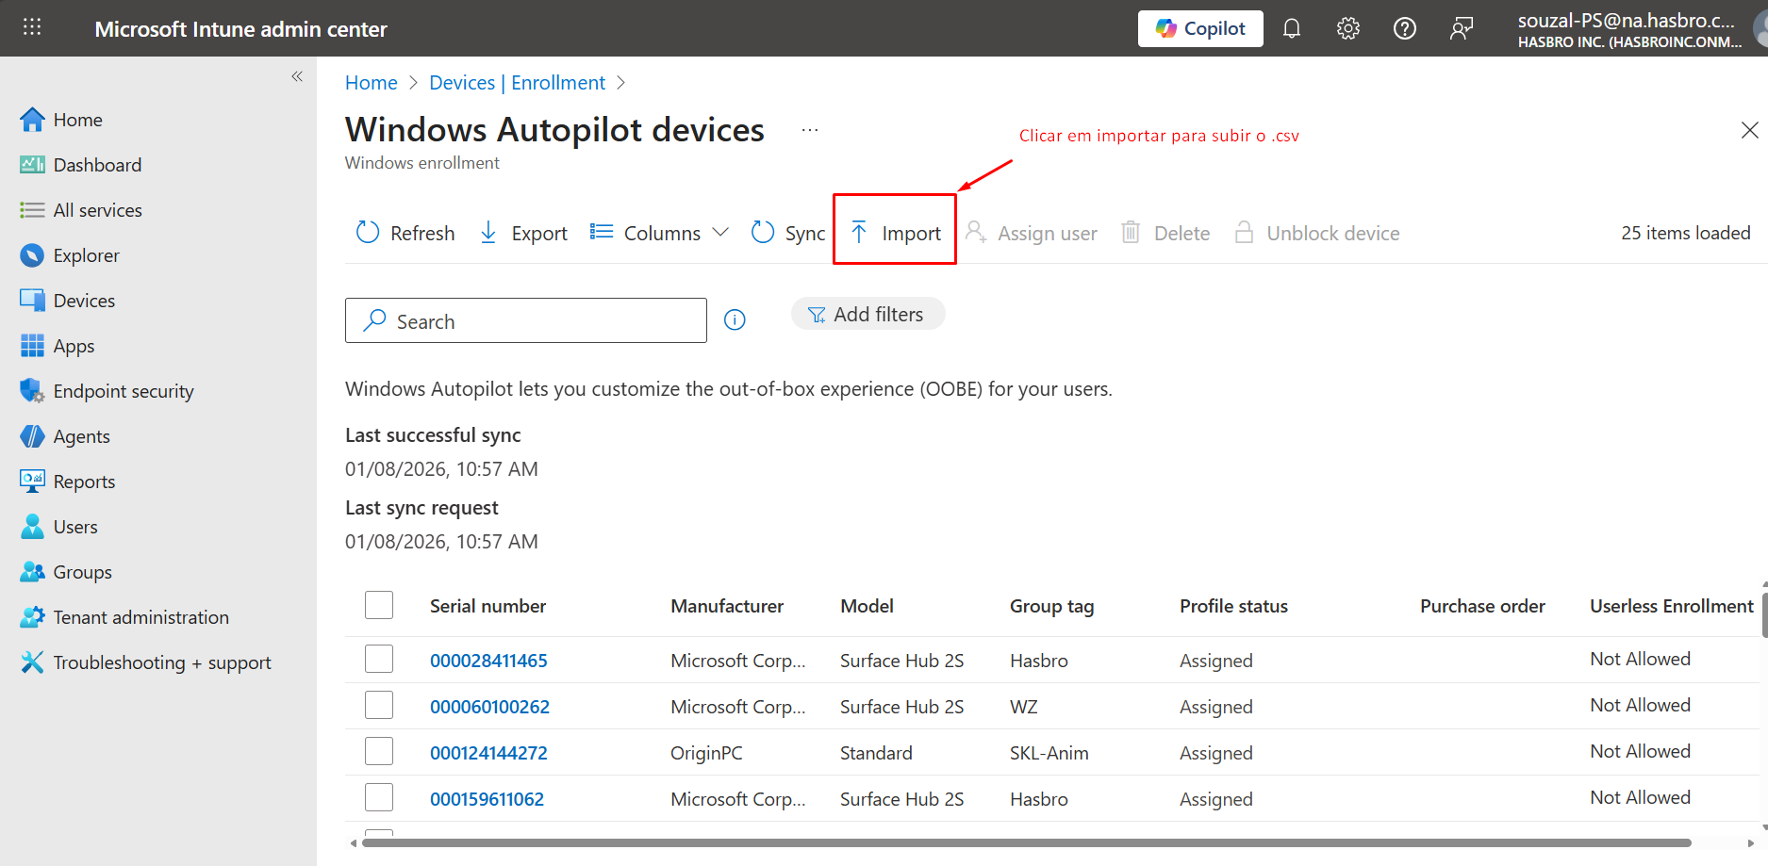
- Select the comphash.csv file created earlier.
- Click Import and wait a few minutes.
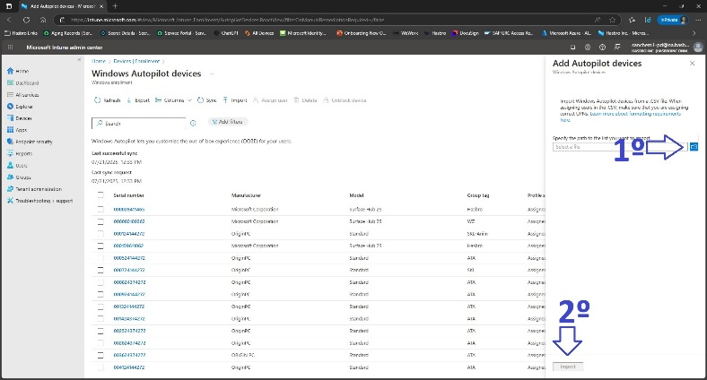
- After locating the device in Search using the ServiceTag, assign the Group Tag 'NA'.
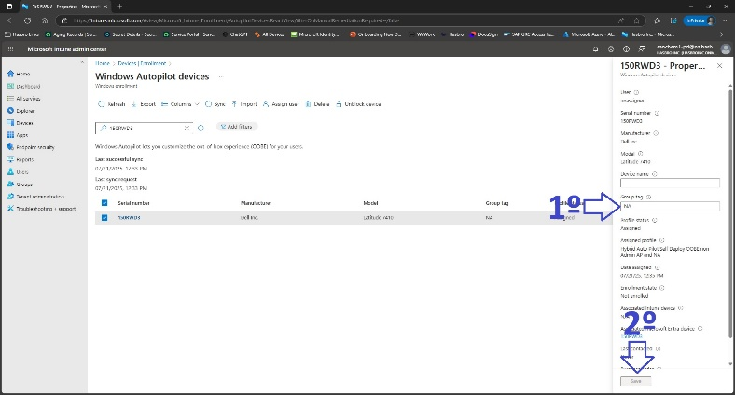
- Refresh until the Group Tag appears correctly.
- Open CMD as Administrator and run: systemreset –factoryreset.
- Choose: Remove Everything.
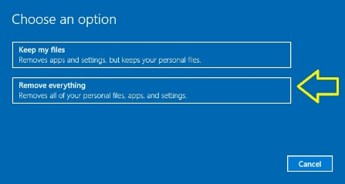
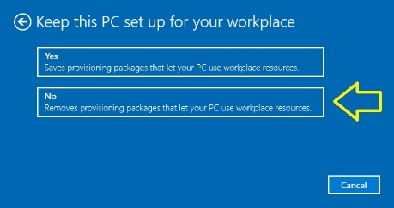
- Then: Remove files and clean the drive.
- Confirm and click Reset.
- If it fails, you can use an external Windows image to perform the installation, and when configuring the account after installation, use a Contoso account (it can be yours, but preferably that of the intended user).
- After the device resets, the process is fully automated. If there are no errors, the device is directed to the LOGON screen:
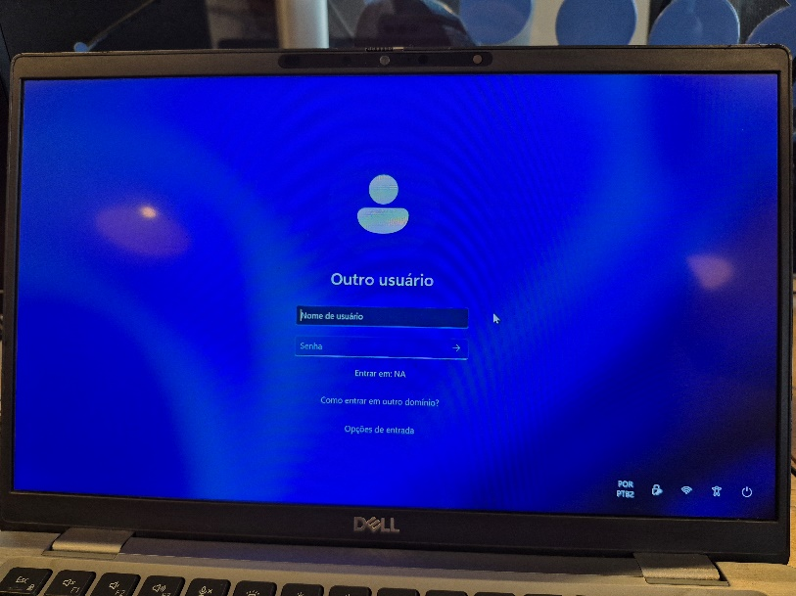
- Click the 'Lock' icon in the lower right corner to open Cisco VPN:
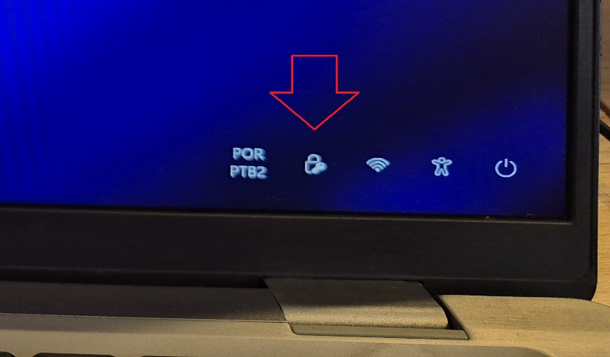
- The Cisco VPN connection window will open already with the correct address for the first connection (connect.contoso.com/autopilot):
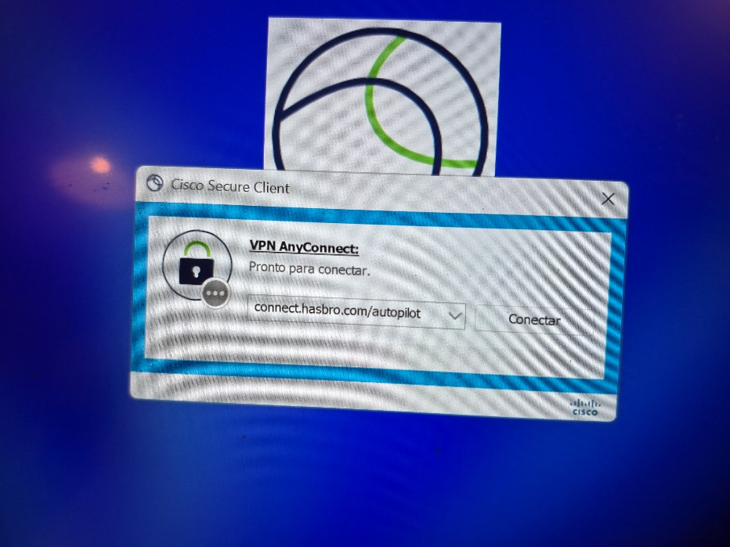
- Click Connect and wait for the window to close.
- A new icon will appear in the system tray:
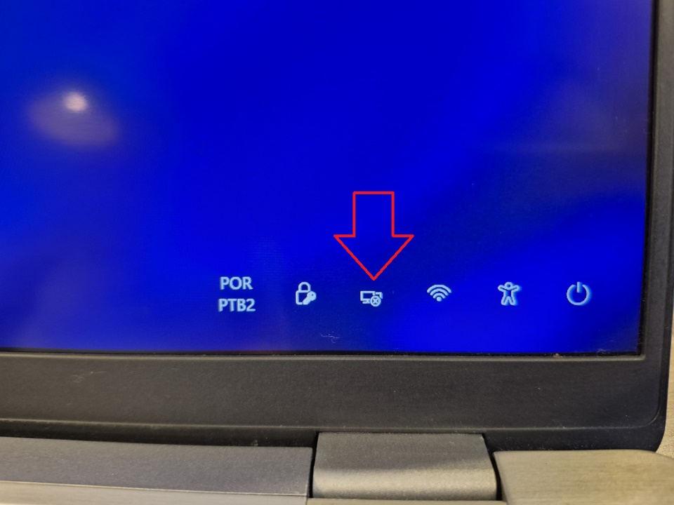
- Now log on normally with the new user's account.
WARNING!!!! >> After logging in once, the VPN icon will disappear as it connects through the credential manager. DO NOT LOG IN WITH ANY ACCOUNT OTHER THAN THE USER'S AT THIS STEP!!! Otherwise you will have to start the entire process over.
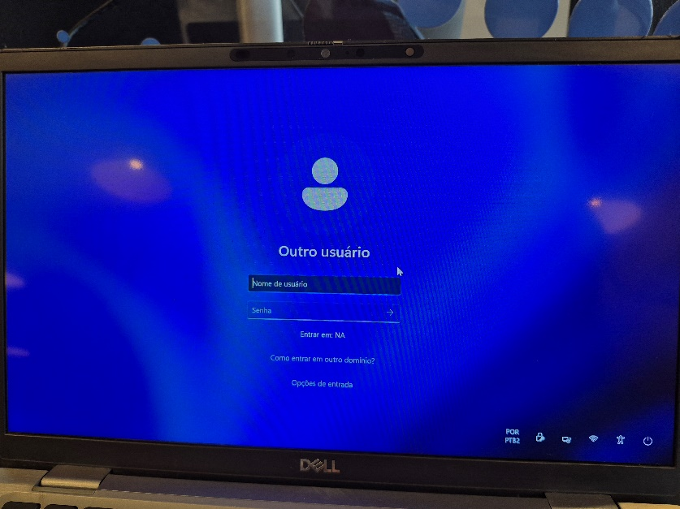
- Finally, AND MOST IMPORTANTLY:
- Confirm that the computer downloads the VPN and WiFi connection Certificate. Without this certificate the user cannot connect to VPN and cannot access ANY systems that require the Contoso network. Open certmgr.msc via Run (Win+R). Navigate to: Personal > Certificates and verify that the certificate Issued by 'Contoso Ent2 CA' is present.
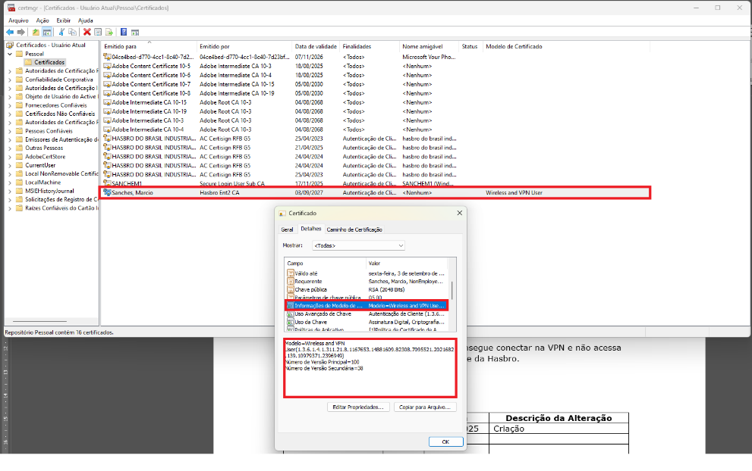
Note: If any issue occurs at any step, the only option is to restart the device formatting process.

Version History
Author | Version | Date | Description
IT Team | 2.0 | 21/07/2025 | Creation
IT Team | 2.1 | 17/11/2025 | Update – VPN Connection.
Lucas P. Souza | 2.2 | 08/01/2026 | Update of .csv instructions and first access after formatting/preparation.
Lucas Souza | — | Jun/2026 | Document standardization

